R65 SYSTEM
A 6502 PASCAL DEVELOPMENT ENVIRONMENT
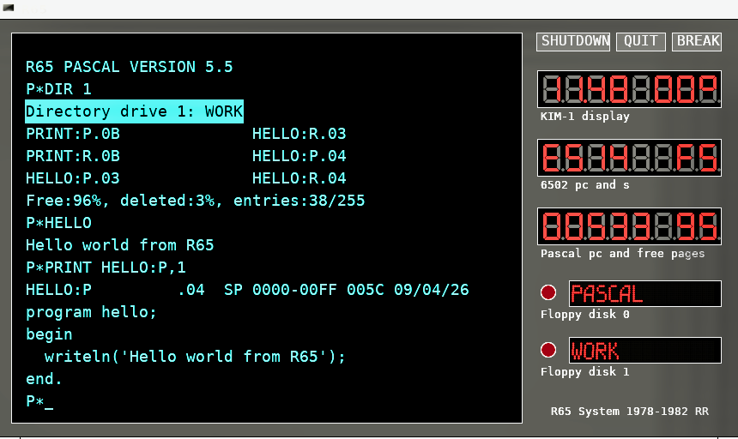

• 6502-based personal computer system (late 1970s)
• Complete Pascal compiler and development environment
• Disk-based workflow with source, work, and system disks
• Integrated editor, viewer, and tools
• Recreated today as a Linux-based emulator
https://github.com/rricharz/R65

HISTORY
In 1976, early microcomputers such as the MOS Technology KIM-1 and the Apple I marked the beginning of affordable personal computing. The KIM-1 (1976) provided a simple but powerful 6502-based training system, while the Apple I (1976) demonstrated that a complete personal computer could be built around a microprocessor.
In 1977, the R65 project began as an attempt to control a model railroad using a microprocessor. Starting from a KIM-1 board, a complete computer system was built with keyboard, display, and storage. All system software, including assembler, editor, and operating tools, was developed from scratch.
Programs and data were initially stored on audio cassette tapes. Editing was sequential and constrained by limited memory. Despite these limitations, the system evolved step by step, each new capability enabling the next.
The R65 was later extended with floppy disks and a Pascal development system inspired by the work of Niklaus Wirth. The focus was on creating a compact but powerful environment capable of direct hardware interaction.
The system remained in use until the early 1980s, when more powerful personal computers became available. Decades later, the R65 was revived as an emulator, preserving both the software and the experience of working with a self-built microcomputer system.
Today, the R65 demonstrates what was possible with limited hardware, creativity, and persistence.
rricharz@bluewin.ch

